Alec Walker

Complex Games Assessment Task 1

* the purpose of the system,

The goal of this system will generate generic mesh data based on a modified Simplex noise algorithm. This demonstration will focus on generating a bumpy / rough sphere as shown in figure 1.0. I aim to use this

* any libraries it relies on,
* the mathematical operations to be used,
* the advanced algorithms to be implemented,
* how it will be made modular, and

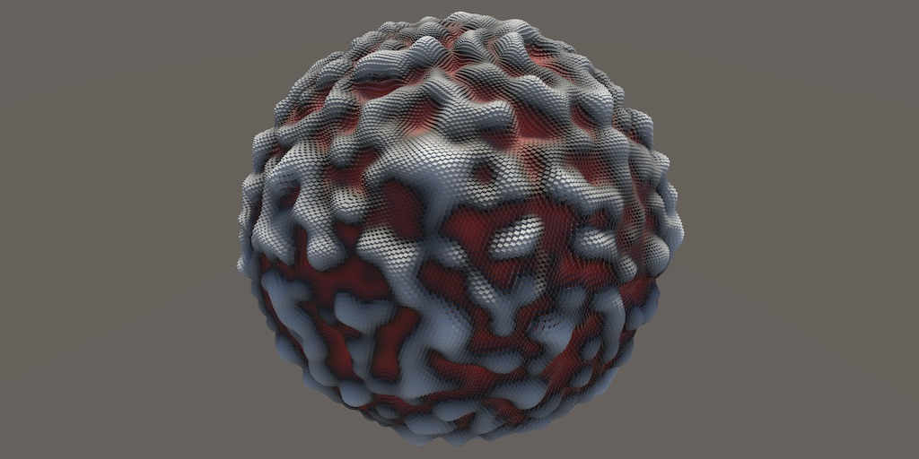

* how to integrate your system with a new or existing application.

I’ll integrate this system into both unity and my previous OpenGL application as the data I’ll be generating should be arbitrary mesh data, which my application is already setup to render.

Figure 1.0